Input Validation and Output Verification
Firebase + CRUD + Feature Testing

Sample JSON Data : Students.json

[
{
"id": 1,
"name": "Maria Santos",
"section": "7-Ampere",
"subjects": {
"Math2": 1.5,
"Math3": 1.75,
"Biology1": 2.0,
"Chem1": 1.25,
"Physics1": 1.75,
"Computer Science2": 1.25,
"PEHM2": 1.0,
"VE2": 1.75,
"Social Science2": 1.5,
"English2": 1.25,
"Filipino2": 1.75
}
},
{
"id": 2,
"name": "Juan Dela Cruz",
"section": "7-Curie",
"subjects": {
"Math2": 2.5,
"Math3": 2.75,
"Biology1": 2.0,
"Chem1": 2.25,
"Physics1": 2.5,
"Computer Science2": 2.0,
"PEHM2": 1.75,
"VE2": 2.5,
"Social Science2": 2.25,
"English2": 2.0,
"Filipino2": 2.75
}
},
{
"id": 3,
"name": "Ana Reyes",
"section": "7-Rutherford",
"subjects": {
"Math2": 1.0,
"Math3": 1.25,
"Biology1": 1.5,
"Chem1": 1.0,
"Physics1": 1.25,
"Computer Science2": 1.0,
"PEHM2": 1.25,
"VE2": 1.25,
"Social Science2": 1.0,
"English2": 1.25,
"Filipino2": 1.5
}
},
{
"id": 4,
"name": "Carlo Mendoza",
"section": "7-Newton",
"subjects": {
"Math2": 2.75,
"Math3": 3.0,
"Biology1": 2.5,
"Chem1": 2.75,
"Physics1": 2.5,
"Computer Science2": 2.25,
"PEHM2": 2.0,
"VE2": 2.5,
"Social Science2": 2.25,
"English2": 2.75,
"Filipino2": 2.5
}
},
{
"id": 5,
"name": "Liza Villanueva",
"section": "7-Ampere",
"subjects": {
"Math2": 1.25,
"Math3": 1.5,
"Biology1": 1.75,
"Chem1": 1.25,
"Physics1": 1.5,
"Computer Science2": 1.0,
"PEHM2": 1.25,
"VE2": 1.0,
"Social Science2": 1.25,
"English2": 1.25,
"Filipino2": 1.5
}
},
{
"id": 6,
"name": "Pedro Cruz",
"section": "7-Curie",
"subjects": {
"Math2": 3.0,
"Math3": 2.75,
"Biology1": 2.5,
"Chem1": 3.0,
"Physics1": 2.75,
"Computer Science2": 2.5,
"PEHM2": 2.0,
"VE2": 2.5,
"Social Science2": 2.75,
"English2": 3.0,
"Filipino2": 2.75
}
},
{
"id": 7,
"name": "Sofia Ramos",
"section": "7-Rutherford",
"subjects": {
"Math2": 1.75,
"Math3": 2.0,
"Biology1": 2.25,
"Chem1": 2.0,
"Physics1": 1.75,
"Computer Science2": 1.5,
"PEHM2": 1.25,
"VE2": 1.75,
"Social Science2": 2.0,
"English2": 1.5,
"Filipino2": 1.75
}
},
{
"id": 8,
"name": "Miguel Torres",
"section": "7-Newton",
"subjects": {
"Math2": 2.25,
"Math3": 2.5,
"Biology1": 2.75,
"Chem1": 2.5,
"Physics1": 2.25,
"Computer Science2": 2.0,
"PEHM2": 2.25,
"VE2": 2.0,
"Social Science2": 2.25,
"English2": 2.5,
"Filipino2": 2.75
}
},
{
"id": 9,
"name": "Grace Lim",
"section": "7-Ampere",
"subjects": {
"Math2": 1.0,
"Math3": 1.25,
"Biology1": 1.0,
"Chem1": 1.25,
"Physics1": 1.0,
"Computer Science2": 1.0,
"PEHM2": 1.25,
"VE2": 1.0,
"Social Science2": 1.25,
"English2": 1.0,
"Filipino2": 1.25
}
},
{
"id": 10,
"name": "Andrei Bautista",
"section": "7-Curie",
"subjects": {
"Math2": 2.5,
"Math3": 2.75,
"Biology1": 3.0,
"Chem1": 2.5,
"Physics1": 2.25,
"Computer Science2": 2.5,
"PEHM2": 2.25,
"VE2": 2.75,
"Social Science2": 3.0,
"English2": 2.75,
"Filipino2": 2.5
}
}
]

Screenshot of Firebase (Realtime Database)
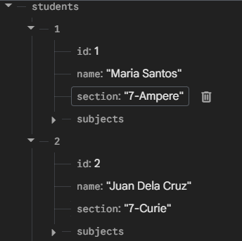
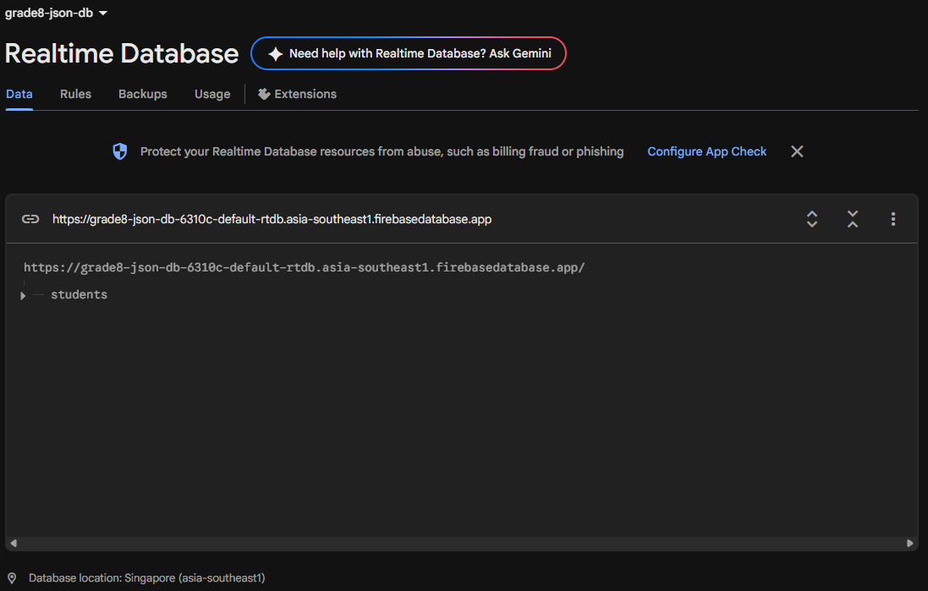

PART A: INPUT VALIDATION

Test Case # | Field | Test Input | Expected Behavior | Actual Output | ✔/✘ | Remarks
1 | General average | 2 | Display the general average of the student | The general average for Juan Dela Cruz (ID: 2) is: 2.30 | ✔
2 | General average | 12 | Reject input | Student with ID 11 not found in the database. | ✔
3 | Display students | No input, with record | Print the student record | Printed the entire student record | ✔
4 | Display students | No input, no record | Reject task | "No records found." | ✔
5 | Update student | 2 | Shows interface to allow updating the specified record | Shows interface to update information for Juan dela Cruz | ✔
6 | Update student | -1 | Reject input | "Student not found." | ✔
7 | Remove student | 11 | Removes the specified student record | Removed student and data under ID 11 | ✔
8 | Remove student | 12 | Reject input | "Record not found." | ✔
9 | Exit | 5 | Terminates program | Terminates the program | ✔
10 | Student database | 1 | Runs code that is set on 1 | Runs the code that prints the student record | ✔
11 | Student database | 7 | Reject input | "Invalid choice. Please try again." | ✔

PART B: CRUD TESTING

Operation | Test Scenario | Expected Result | Actual Result | ✔/✘ | Remarks
Create | Add “Lithium Alkali” | Adds specified student | Lithium Alkali added | ✔
Read | Display all | Displays the current student record | Printed entire student record | ✔
Update | Update Lithium Alkali’s Math 2 grade | Shows updated value | Updated Alkali’s Math 2 grade | ✔
Delete | Delete “Lithium Alkali” | Removes specified student | Removed Lithium Alkali | ✔

PART C: OUTPUT VERIFICATION

Test Case # | Input Data | Expected Output | Actual Output | ✔/✘ | Remarks
Display Format Verification
1 | Sofia Ramos | Proper format in student record | --- Record for Sofia Ramos (ID: 7) ---  Section: 7-Rutherford  Subject | Grade  ---------------------------------  Biology1 | 2.25  Chem1 | 2.0  Computer Science2 | 1.5  English2 | 1.5  Filipino2 | 1.75  Math2 | 1.75  Math3 | 2.0  PEHM2 | 1.25  Physics1 | 1.75  Social Science2 | 2.0  VE2 | 1.75 | ✔
Calculation/Logic Verification
2 | 2.0, 1.25, 1.25, 1.25, 1.75, 1.5, 1.75, 1.0, 1.75, 1.5, 1.75 | Average = 1.545454… rounded off 1.55 | 1.52 | ✘

PART D: FEATURE / QUERY TESTING

Feature | Test Input | Expected Output | Actual Output | ✔/✘ | Remarks
Display average grade | N/A | Displays average grade for all students | Maria Santos: 1.50  Juan Dela Cruz: 2.30  Ana Reyes: 1.20  Carlo Mendoza: 2.52  Liza Villanueva: 1.32  Pedro Cruz: 2.68  Sofia Ramos: 1.77  Miguel Torres: 2.36  Grace Lim: 1.11  Andrei Bautista: 2.61 | ✔
Display highest grade | N/A |  | Maria Santos: PEHM2 - 1.00  Juan Dela Cruz: PEHM2 - 1.75  Ana Reyes: Chem1, Computer Science2, Math2, Social Science2 - 1.00  Carlo Mendoza: PEHM2 - 2.00  Liza Villanueva: Computer Science2, VE2 - 1.00  Pedro Cruz: PEHM2 - 2.00  Sofia Ramos: PEHM2 - 1.25  Miguel Torres: Computer Science2, VE2 - 2.00  Grace Lim: Biology1, Computer Science2, English2, Math2, Physics1, VE2 - 1.00  Andrei Bautista: PEHM2, Physics1 - 2.25 | ✔
Display lowest grade | N/A |  | Maria Santos: Biology1 - 2.00  Juan Dela Cruz: Filipino2, Math3 - 2.75  Ana Reyes: Biology1, Filipino2 - 1.50  Carlo Mendoza: Math3 - 3.00  Liza Villanueva: Biology1 - 1.75  Pedro Cruz: Chem1, English2, Math2 - 3.00  Sofia Ramos: Biology1 - 2.25  Miguel Torres: Biology1, Filipino2 - 2.75  Grace Lim: Chem1, Filipino2, Math3, PEHM2, Social Science2 - 1.25  Andrei Bautista: Biology1, Social Science2 - 3.00 | ✔
Exit Features menu | N/A | Closes features menu | Exited features menu | ✔
Exit features and main menu | N/A | Closes both menus | Exited the program | ✔

PART E: ERROR HANDLING

Test Case # | Scenario | Expected Result | Actual Result | ✔/✘ | Remarks
1 | Invalid input | Show error | Error shown | ✔
2 | Empty input | Prevent save | Blocked | ✔

Prepared by: Mickael Fermil S. Daradar
Verified by: Mickael Fermil S. Daradar

